Batch: A1 Roll No.: 16010123012

Experiment / Assignment / Tutorial No.: 08

Title: Basic Reinforcement Learning using Q-Learning – Virtual Lab

Aim: To understand the fundamentals of Reinforcement Learning (RL ) using the Virtual Labs simulator
Expected Outcome of Experiment:

CO5: Gain a basic understanding of Reinforcement Learning (RL) principles and its potential applications.

Books/ Journals/ Websites referred:
- Stuart Russell & Peter Norvig — Artificial Intelligence: A Modern Approach
- Richard Sutton & Andrew Barto — Reinforcement Learning: An Introduction
- Tom Mitchell — Machine Learning
- https://www.ibm.com/think/topics/reinforcement-learning
- https://ai1-iiith.vlabs.ac.in/exp/q-learning/index.html

Reinforcement Learning is a learning technique where an agent learns by interacting with an environment through trial and error and improves its performance using rewards and penalties.

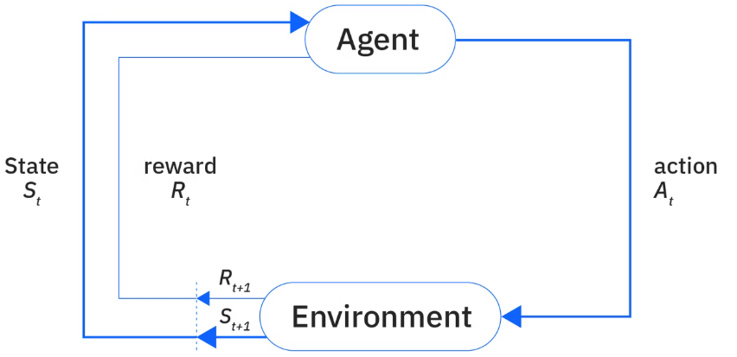

Components of Reinforcement Learning

Agent - Learner or decision maker
Example:
Robot, game player, navigation system

Environment - World in which the agent operates
Example:
Gridworld simulation

State (S)- Current position or situation of agent
Example:
Cell location inside grid

Action (A)- Possible moves agent can take
Example:
- Move Up
- Move Down
- Move Left
- Move Right

Reward (R)- Feedback received after action
Example:
Action Result | Reward
Correct move | +1
Wrong move | −1
Goal reached | +10

Policy (π) -Strategy followed by agent to choose actions
Goal: Maximize total reward

Virtual Lab Support (Student Activity Steps)
Students should perform this experiment using:
https://ai1-iiith.vlabs.ac.in/exp/q-learning/index.html
Task
- Identify: Start position, Goal position, Reward States, possible movement directions
- Initialize the parameter – Learning Rate, Exploration rate etc.
- Monitor the Q-table updates
- Repeat experiment by changing parameters
Results:
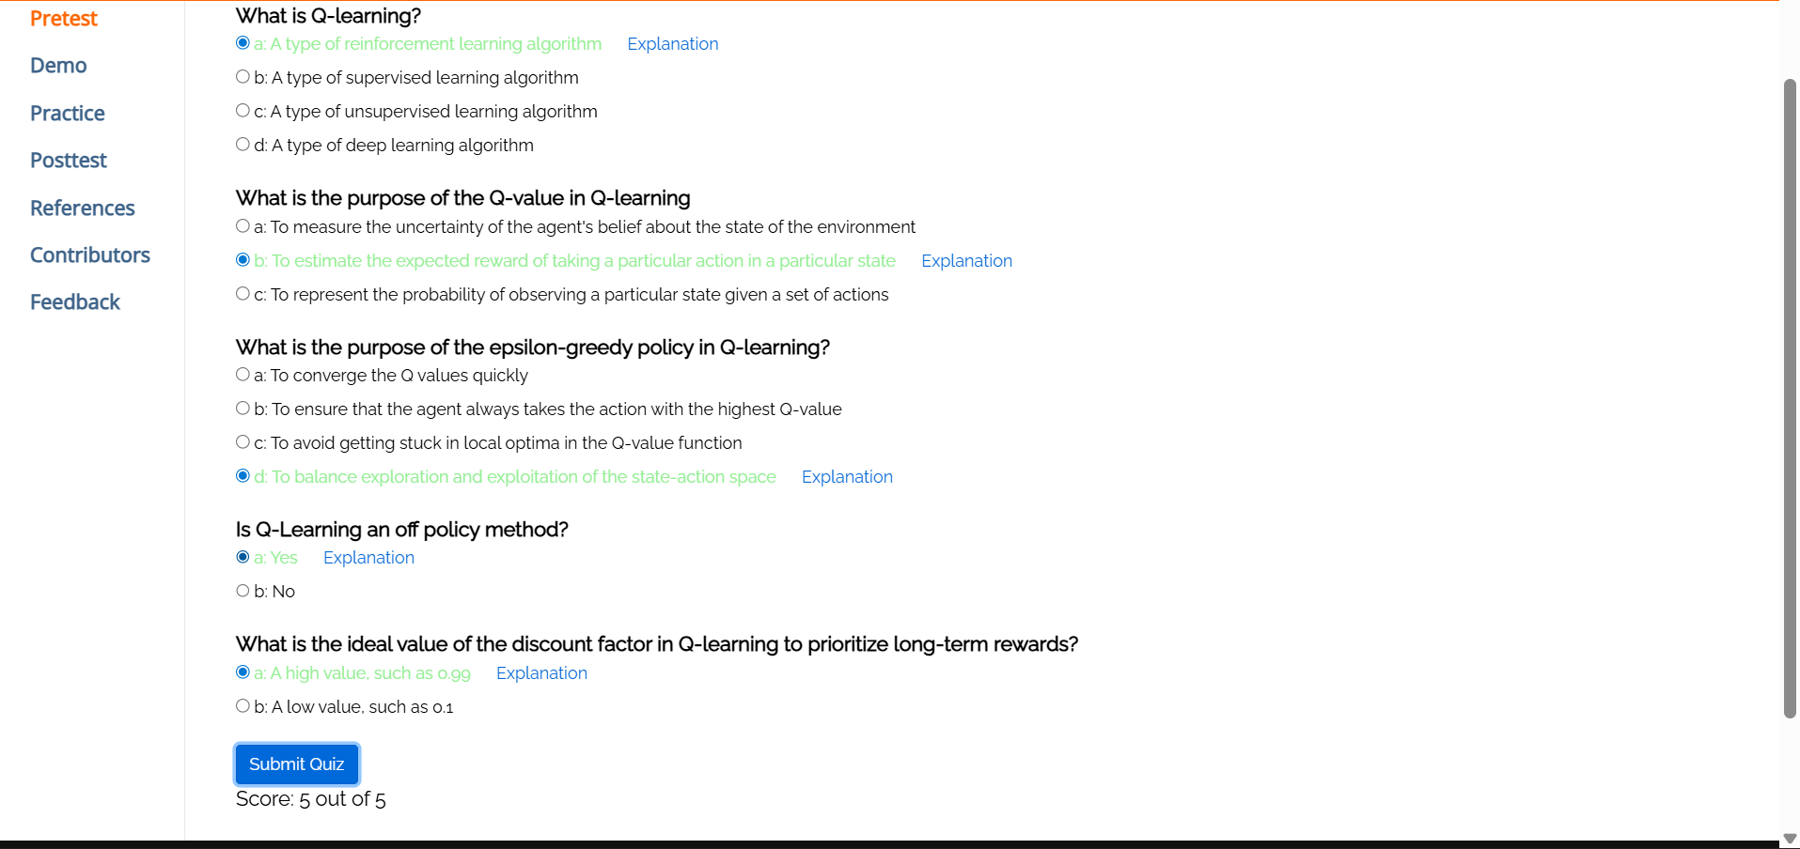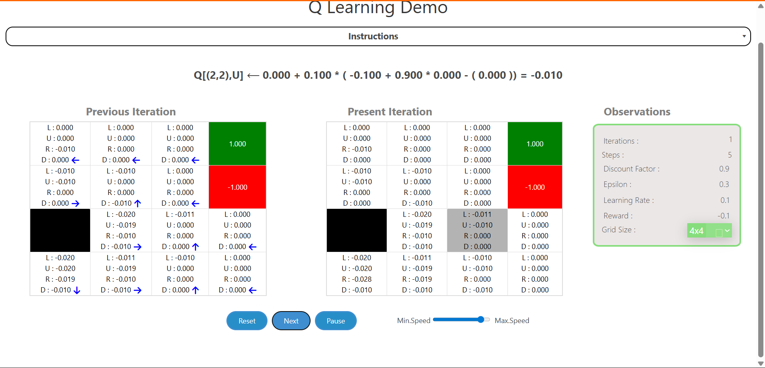

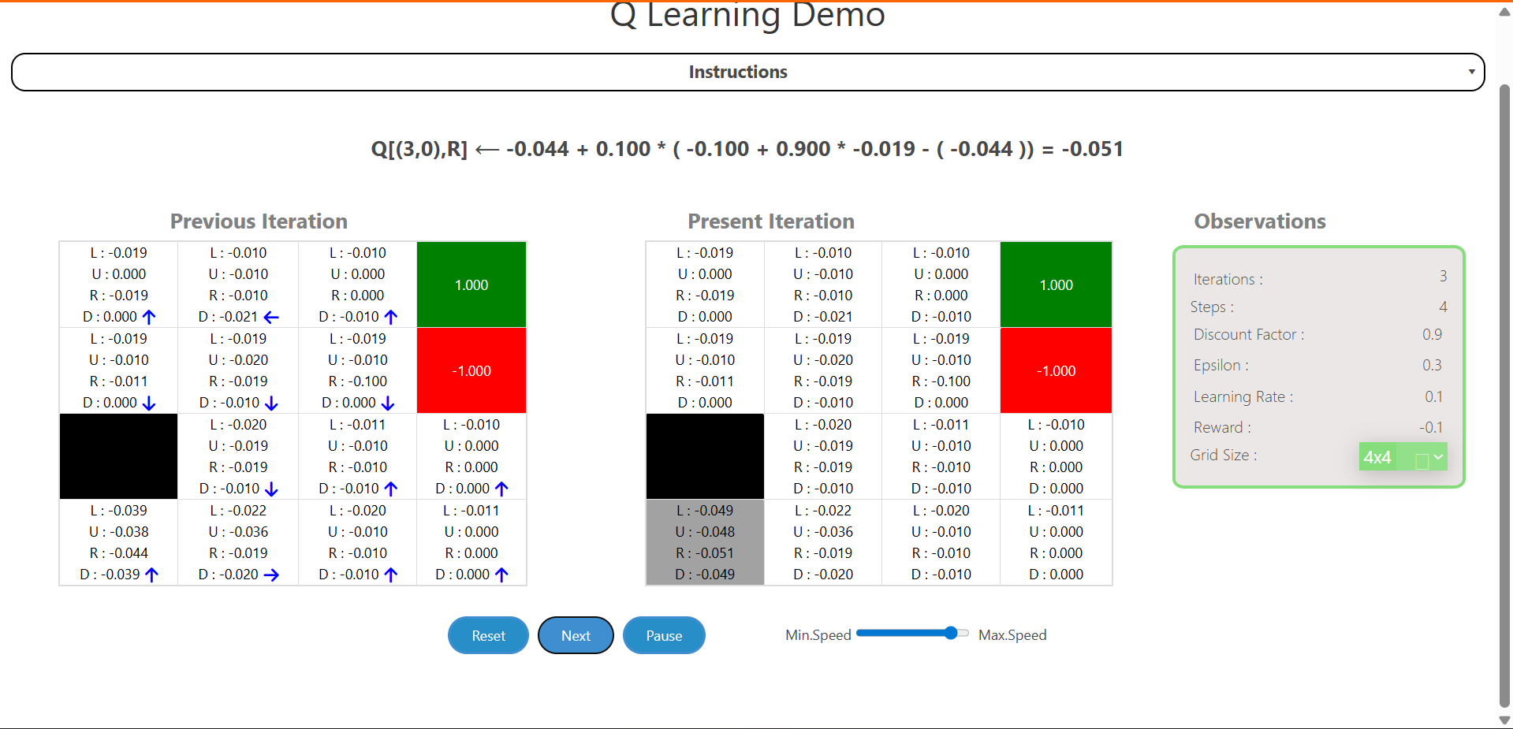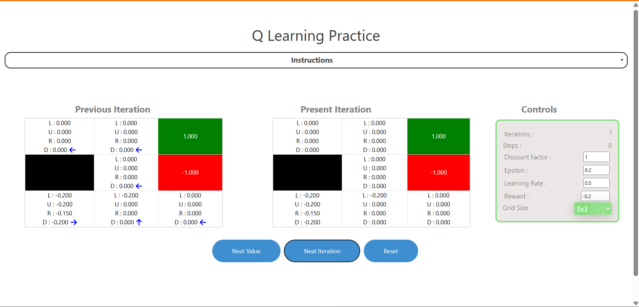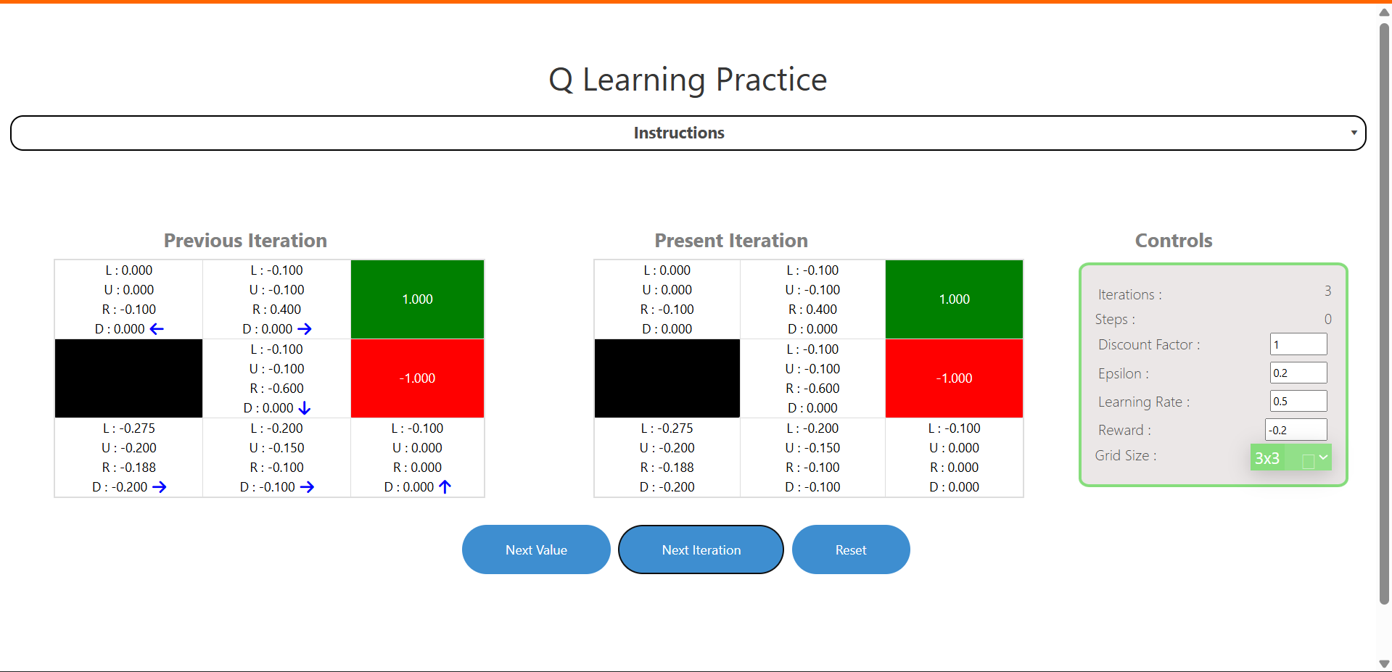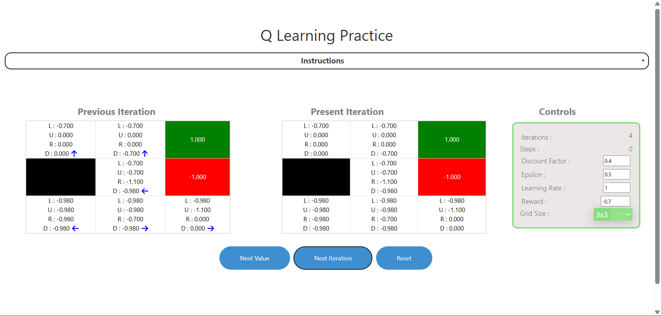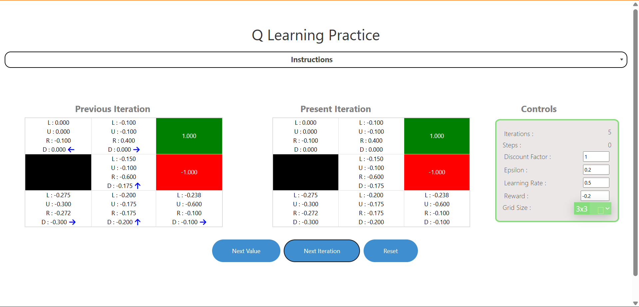

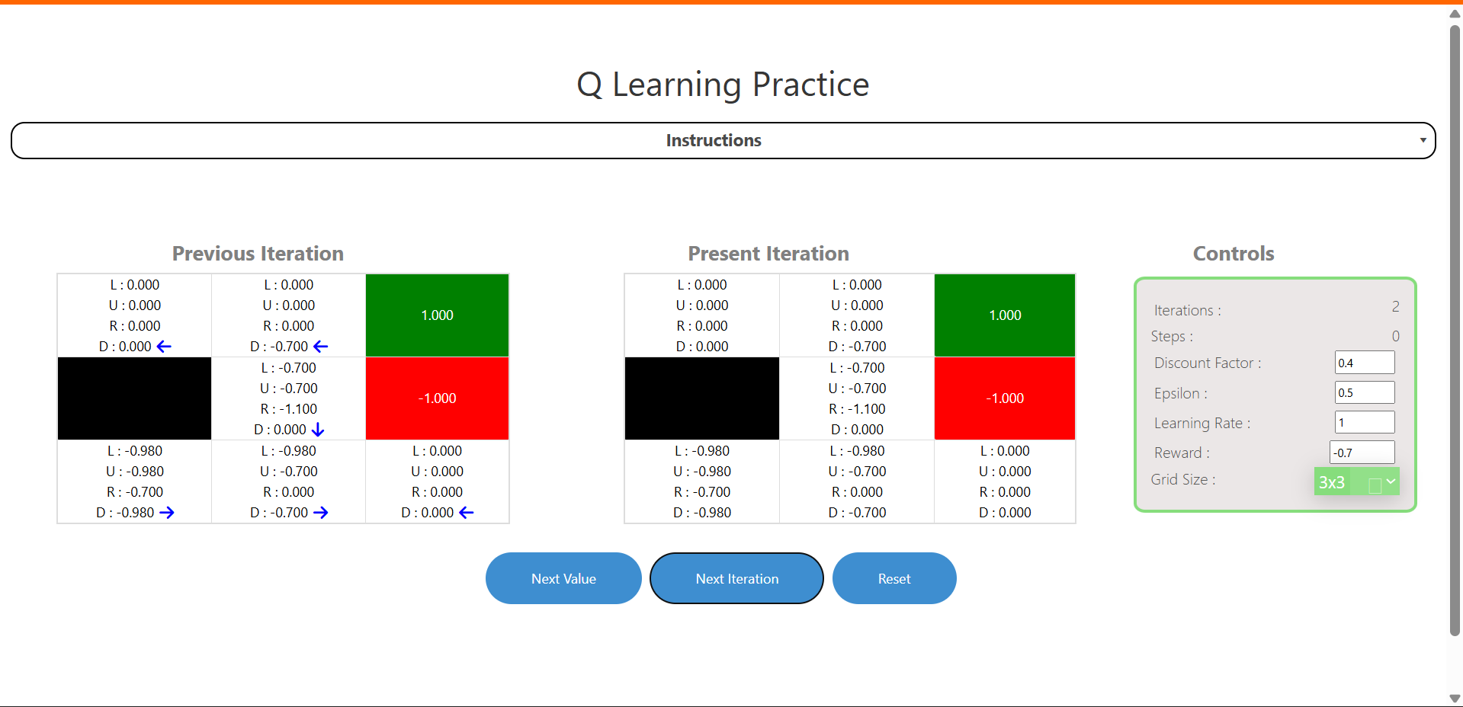
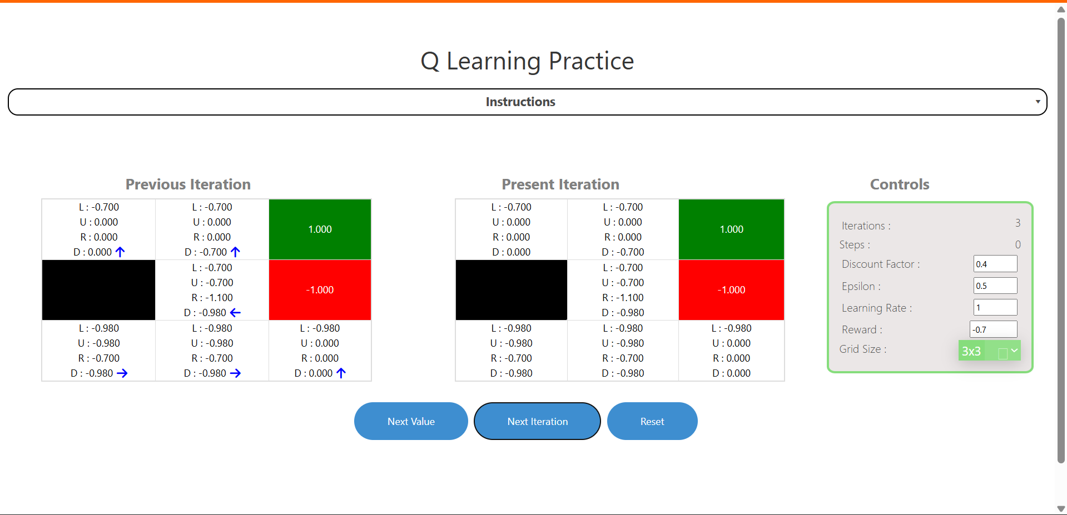
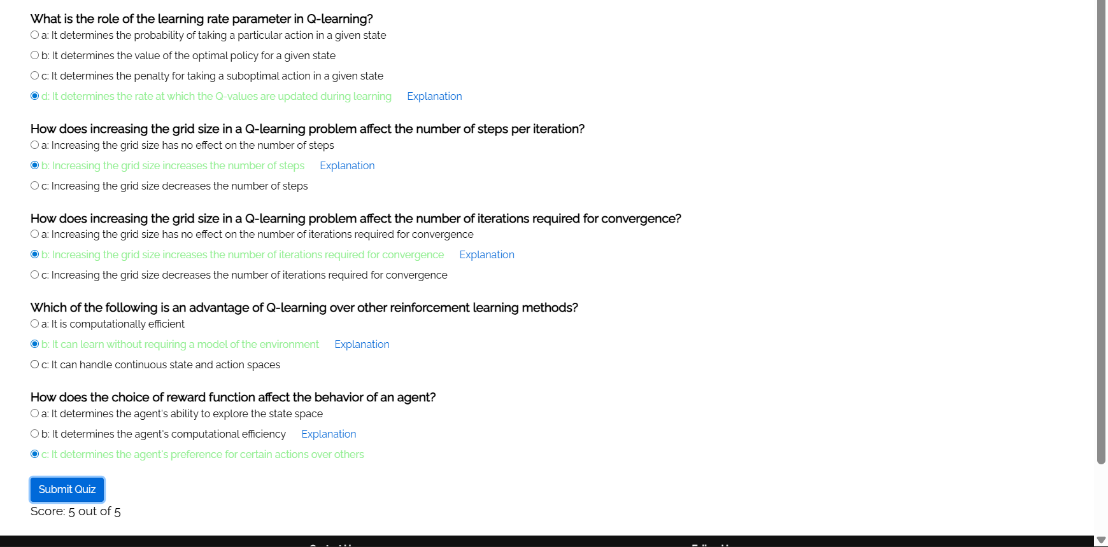
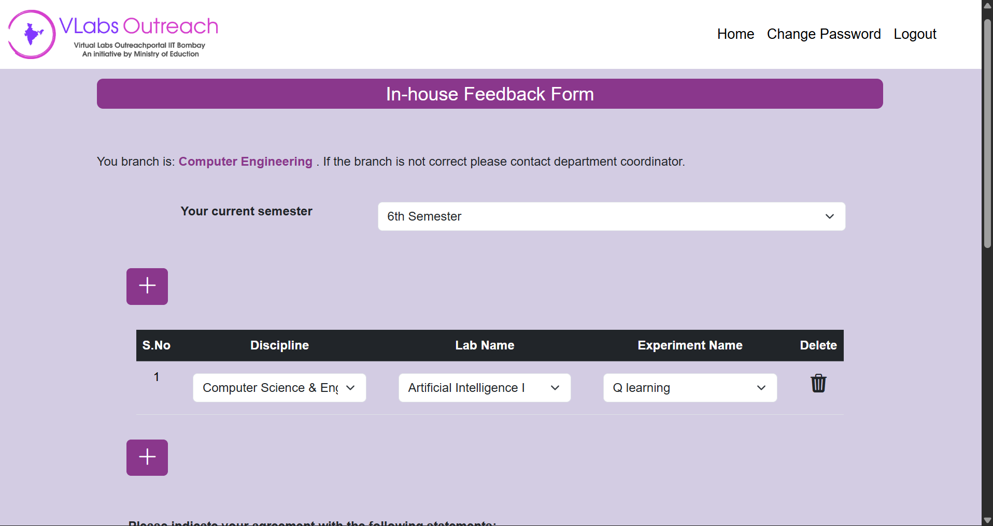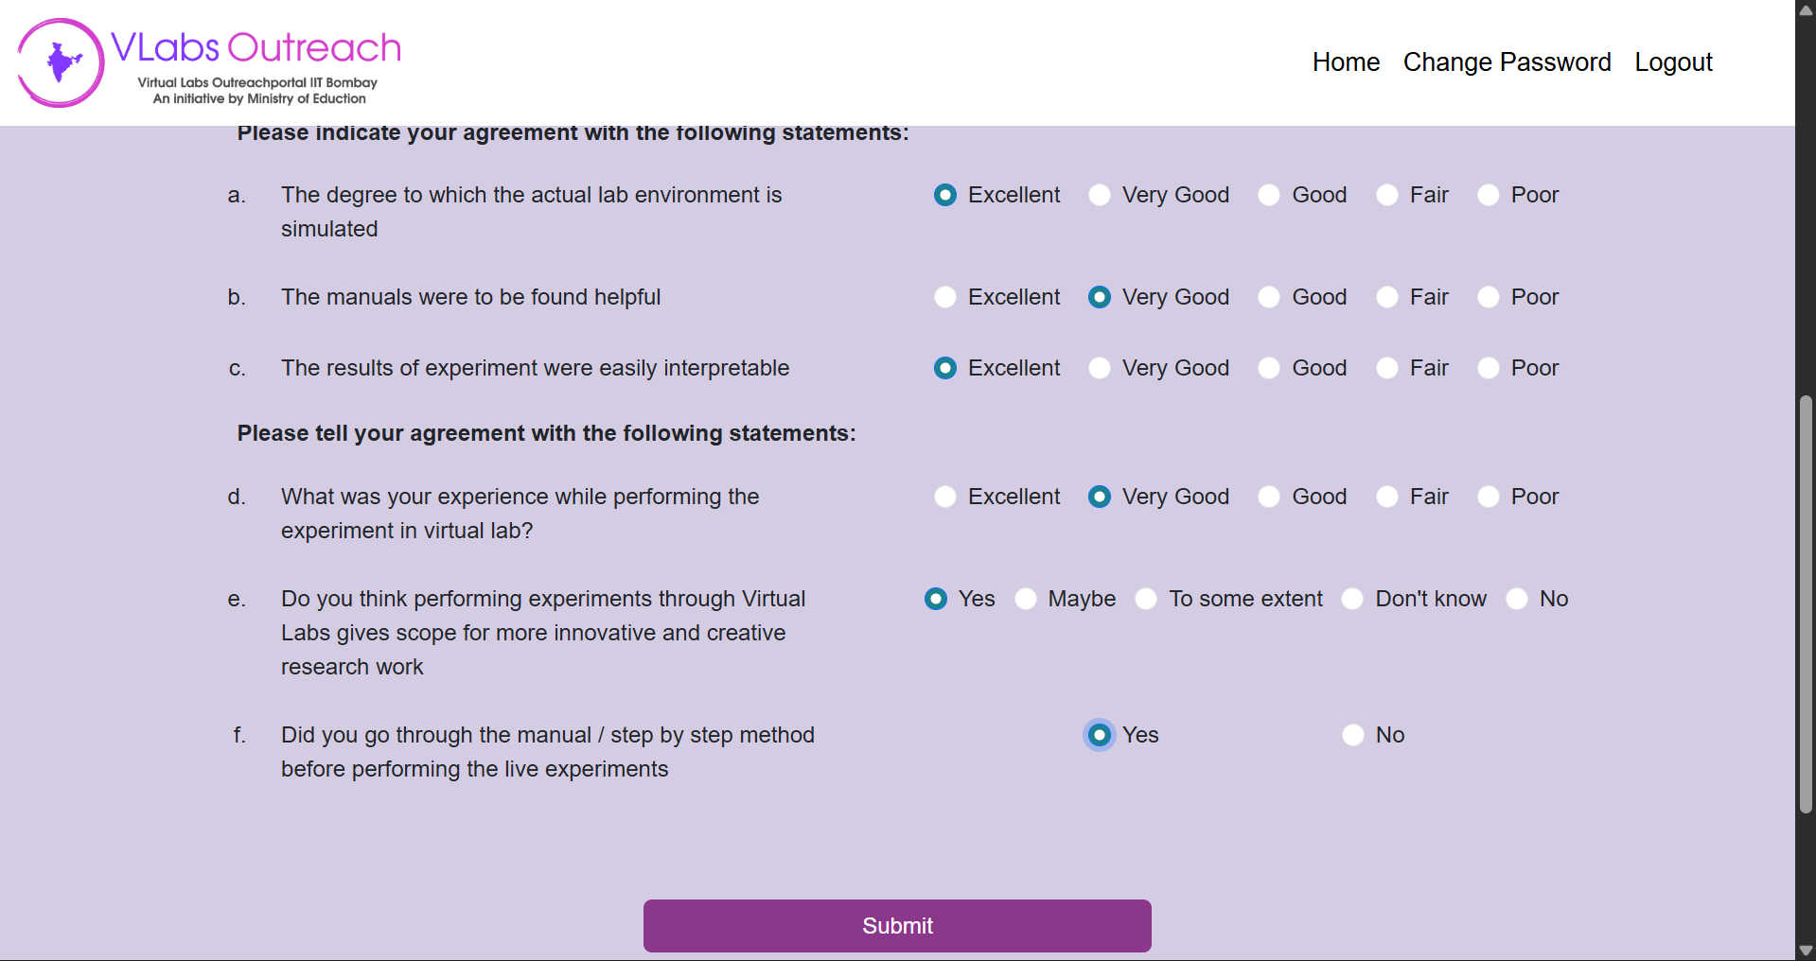
Conclusion:
In this experiment, the fundamentals of Reinforcement Learning were studied using the Q-Learning algorithm in a virtual lab environment. The agent learned to navigate the environment by interacting with it and updating Q-values based on rewards and penalties. Through multiple iterations, the agent improved its policy to maximize cumulative reward and reach the goal efficiently. The experiment demonstrated how learning rate, exploration rate, and reward structure influence the learning process. Overall, it highlights that Q-Learning is an effective model-free approach for solving sequential decision-making problems.

Post Lab :
- Define Reinforcement Learning and explain how it differs from supervised learning.
Reinforcement Learning (RL) is a learning paradigm where an agent learns by interacting with an environment and receiving rewards or penalties based on its actions. The goal is to learn an optimal policy that maximizes cumulative reward over time. Unlike supervised learning, RL does not rely on labeled input-output pairs. Instead, feedback is delayed and comes in the form of rewards. In contrast, supervised learning uses a labeled dataset where the correct output is known for each input, and the model learns by minimizing prediction error. RL focuses on sequential decision-making and exploration, whereas supervised learning focuses on direct mapping from inputs to outputs.

- What is a policy in Reinforcement Learning?
A policy is a strategy or rule that defines how an agent selects actions based on the current state. It determines the behavior of the agent in the environment. A policy can be deterministic, where a specific action is chosen for each state, or stochastic, where actions are chosen based on probabilities. The objective of reinforcement learning is to learn an optimal policy that maximizes the expected cumulative reward over time.

